CSE325

(Team Number)

(12BCE0105, 12BCE0552, 12BCE0603)

Software Requirements Specification

Document

Version: (1) Date: (23/2/2015)

Table of Contents

1. Introduction
1.1 Purpose
1.2 Scope
1.3 Definitions, Acronyms, and Abbreviations
1.4 References
1.5 Overview

2. The Overall Description
2.1 Product Perspective
2.1.1 System Interfaces
2.1.2 Interfaces
2.1.3 Hardware Interfaces
2.1.4 Software Interfaces
2.1.5 Communications Interfaces
2.1.6 Memory Constraints
2.1.7 Operations
2.1.8 Site Adaptation Requirements
2.2 Product Functions
2.3 User Characteristics
2.4 Constraints
2.5 Assumptions and Dependencies
2.6 Apportioning of Requirements

3. Specific Requirements
3.1 External interfaces
3.2 Functions
3.3 Performance Requirements
3.4 Logical Database Requirements
3.5 Design Constraints
3.5.1 Standards Compliance
3.6 Software System Attributes
3.6.1 Reliability
3.6.2 Availability
3.6.3 Security
3.6.4 Maintainability
3.6.5 Portability
3.7 Organizing the Specific Requirements
3.7.1 System Mode
3.7.2 User Class
3.7.3 Objects
3.7.4 Feature
3.7.5 Stimulus
3.7.6 Response
3.7.7 Functional Hierarchy
3.8 Additional Comments

4. Change Management Process

5. Document Approvals

6. Supporting Information

1. Introduction

We are intend to develop a software on Who am I? and a tic-tac toe game.In the who am I? game the player is asked to think of a famous celebrity. A set of questions is then asked and based on the responses, the celebrity is guessed by the software.In the game of Tic-TacToe, one of the players is allowed to login to the software so that he knows all the possible strategic moves to his opponent’s moves and hence will always win.

1.1 Purpose

The purpose of both these games is basically for fun and entertainment of the user.User can simply play the games.The game is meant to be for all age groups.The software uses its knowledge of guessing which inturn makes both the games an amazement for the player.Its a fully a fun-purpose game.

1.2 Scope

- Design a databse containing the information about all the celebrities.
- Use of html,javascript and css inorder to develop webpages of the games we intend to develop.
- The software is portable and can be used anywhere.
- Who am I ?-In this game we need to make the users surprise with accurate answers.
- Tic-Tac Toe-In this the user knows all the possible strategic moves to his opponent’s moves and hence always wins.

1.3 Definitions, Acronyms, and Abbreviations.

Provide the definitions of all terms, acronyms, and abbreviations required to properly interpret the SRS. This information may be provided by reference to one or more appendices in the SRS or by reference to documents. This information may be provided by reference to an Appendix.

1.4 References

(1) http://en.wikipedia.org/wiki/List_of_Indian_film_actors
(2) http://www.wired.com/2013/06/how-does-the-web-genie-work/
(3) http://ostermiller.org/tictactoeexpert.html

2. The Overall Description

(i) Who Am I?
The idea of this game originates from an European version of it to guess celebrities. The algorithms that have been plied include a binary search from a decision tree that contain the database of celebrities. The aim is to find the celebrity in at most 20 questions.
The domain of the database can include 2^20=1,048,576 possibilities. A unique combination of the 20 answers gives the name of the celebrity. The questions are designed such that the combination of answers is unique.
It is a time-killer application that targets users of any age group for entertainment purpose.
(ii) Tic Tac Toe
This is a well-known game played between 2 players in a 3x3 grid. However,making only one player win always is the task of the application.
The domain of the game covers all the possible combinations of 0’s and x’s.
It is a game designed for users of all age groups.

2.1 Product Perspective

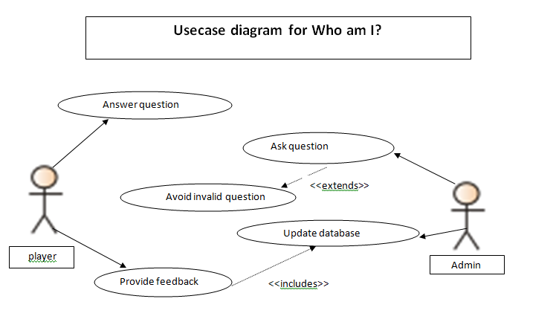

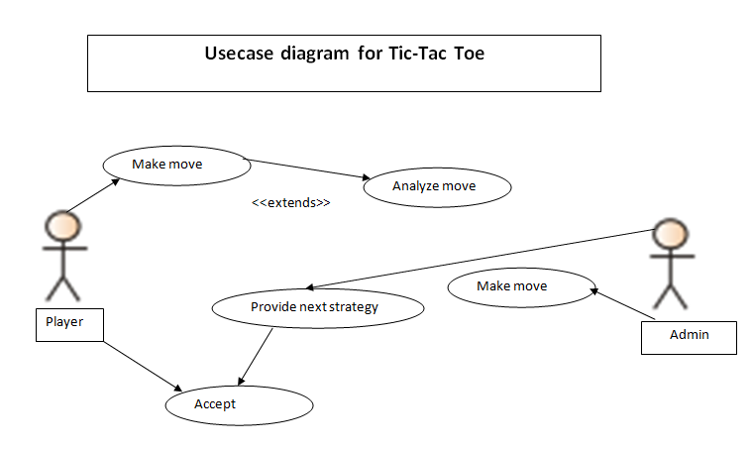

2.1.1 System Interfaces

List each system interface and identify the functionality of the software to accomplish the system requirement and the interface description to match the system. These are external systems that you have to interact with. For instance, if you are building a business application that interfaces with the existing employee payroll system, what is the API to that system that designer’s will need to use?

2.1.2 Interfaces

Specify:
- The logical characteristics of each interface between the software product and its users.
- All the aspects of optimizing the interface with the person who must use the system

This is a description of how the system will interact with its users. Is there a GUI, a command line or some other type of interface? Are there special interface requirements? If you are designing for the general student population for instance, what is the impact of ADA (American with Disabilities Act) on your interface?

2.1.3 Hardware Interfaces

Specify the logical characteristics of each interface between the software product and the hardware components of the system. This includes configuration characteristics. It also covers such matters as what devices are to be supported, how they are to be supported and protocols. This is not a description of hardware requirements in the sense that “This program must run on a Mac with 64M of RAM”. This section is for detailing the actual hardware devices your application will interact with and control. For instance, if you are controlling X10 type home devices, what is the interface to those devices? Designers should be able to look at this and know what hardware they need to worry about in the design. Many business type applications will have no hardware interfaces. If none, just state “The system has no hardware interface requirements” If you just delete sections that are not applicable, then readers do not know if: a. this does not apply or b. you forgot to include the section in the first place.

2.1.4 Software Interfaces

Specify the use of other required software products and interfaces with other application systems. For each required software product, include:
- Name
- Mnemonic
- Specification number
- Version number
- Source

For each interface, provide:
- Discussion of the purpose of the interfacing software as related to this software product
- Definition of the interface in terms of message content and format

Here we document the APIs, versions of software that we do not have to write, but that our system has to use. For instance if your customer uses SQL Server 7 and you are required to use that, then you need to specify i.e.
2.1.4.1 Microsoft SQL Server 7. The system must use SQL Server as its database component. Communication with the DB is through ODBC connections. The system must provide SQL data table definintions to be provided to the company DBA for setup.

A key point to remember is that you do NOT want to specify software here that you think would be good to use. This is only for customer-specified systems that you have to interact with. Choosing SQL Server 7 as a DB without a customer requirement is a Design choice, not a requirement. This is a subtle but important point to writing good requirements and not over-constraining the design.

2.1.5 Communications Interfaces

Specify the various interfaces to communications such as local network protocols, etc. These are protocols you will need to directly interact with. If you happen to use web services transparently to your application then do not list it here. If you are using a custom protocol to communicate between systems, then document that protocol here so designers know what to design. If it is a standard protocol, you can reference an existing document or RFC.

2.1.6 Memory Constraints

Specify any applicable characteristics and limits on primary and secondary memory. Don’t just make up something here. If all the customer’s machines have only 128K of RAM, then your target design has got to come in under 128K so there is an actual requirement. You could also cite market research here for shrink-wrap type applications “Focus groups have determined that our target market has between 256-512M of RAM, therefore the design footprint should not exceed 256M.” If there are no memory constraints, so state.

2.1.7 Operations

Specify the normal and special operations required by the user such as:
- The various modes of operations in the user organization
- Periods of interactive operations and periods of unattended operations
- Data processing support functions
- Backup and recovery operations

(Note: This is sometimes specified as part of the User Interfaces section.) If you separate this from the UI stuff earlier, then cover business process type stuff that would impact the design. For instance, if the company brings all their systems down at midnight for data backup that might impact the design. These are all the work tasks that impact the design of an application, but which might not be located in software.

2.1.8 Site Adaptation Requirements

In this section:
- Define the requirements for any data or initialization sequences that are specific to a given site, mission, or operational mode
- Specify the site or mission-related features that should be modified to adapt the software to a particular installation

If any modifications to the customer’s work area would be required by your system, then document that here. For instance, “A 100Kw backup generator and 10000 BTU air conditioning system must be installed at the user site prior to software installation”.
This could also be software-specific like, “New data tables created for this system must be installed on the company’s existing DB server and populated prior to system activation.” Any equipment the customer would need to buy or any software setup that needs to be done so that your system will install and operate correctly should be documented here.

2.2 Product Functions

Provide a summary of the major functions that the software will perform. Sometimes the function summary that is necessary for this part can be taken directly from the section of the higher-level specification (if one exists) that allocates particular functions to the software product.

For clarity:
- The functions should be organized in a way that makes the list of functions understandable to the customer or to anyone else reading the document for the first time.
- Textual or graphic methods can be used to show the different functions and their relationships. Such a diagram is not intended to show a design of a product but simply shows the logical relationships among variables.

AH, Finally the real meat of section 2. This describes the functionality of the system in the language of the customer. What specifically does the system that will be designed have to do? Drawings are good, but remember this is a description of what the system needs to do, not how you are going to build it. (That comes in the design document).

2.3 User Characteristics

Describe those general characteristics of the intended users of the product including educational level, experience, and technical expertise. Do not state specific requirements but rather provide the reasons why certain specific requirements are later specified in section 3.

What is it about your potential user base that will impact the design? Their experience and comfort with technology will drive UI design. Other characteristics might actually influence internal design of the system.

2.4 Constraints

Provide a general description of any other items that will limit the developer's options. These can include:

(1) Regulatory policies
(2) Hardware limitations (for example, signal timing requirements)
(3) Interface to other applications
(4) Parallel operation
(5) Audit functions
(6) Control functions
(7) Higher-order language requirements
- Signal handshake protocols (for example, XON-XOFF, ACK-NACK)
- Reliability requirements
(10) Criticality of the application
(11) Safety and security considerations

This section captures non-functional requirements in the customers language. A more formal presentation of these will occur in section 3.

2.5 Assumptions and Dependencies

List each of the factors that affect the requirements stated in the SRS. These factors are not design constraints on the software but are, rather, any changes to them that can affect the requirements in the SRS. For example, an assumption might be that a specific operating system would be available on the hardware designated for the software product. If, in fact, the operating system were not available, the SRS would then have to change accordingly.

This section is catch-all for everything else that might influence the design of the system and that did not fit in any of the categories above.

2.6 Apportioning of Requirements.

Identify requirements that may be delayed until future versions of the system. After you look at the project plan and hours available, you may realize that you just cannot get everything done. This section divides the requirements into different sections for development and delivery. Remember to check with the customer – they should prioritize the requirements and decide what does and does not get done. This can also be useful if you are using an iterative life cycle model to specify which requirements will map to which interation.

3. Specific Requirements
FUNCTIONAL REQUIREMENTS
Following are the functional requirements for the games: (I.D.s are provided for priority)
i) WHO AM I?
- Attractive front end(4)
As a user, I would like the display page to be colorful and attractive.
- Accuracy(1)
I would like each of the celebrities I think of to be correctly identified. Only such a game will make itself interesting to play.
- Wide range of options(2)
The celebrities available in the game should be of a wide range.
(The database should be huge and correct.)
- Feedback Provision(3)
In case, a celebrity is not available in the database, I should be able to suggest the addition into the database.
ii) TIC TAC TOE
- Attractive front end(2)
As a user, I would like the display page to be colorful and attractive.
- WIN-WIN SITUATION(1)
The game should always allow me to win the game and not the computer or the other non-registered player.
(This step is tedious itself and requires all cases from a user’s view to be considered for a win.)
NON-FUNCTIONAL REQUIREMENTS
Spectators must be able to use the game without prior registration and without prior knowledge of the game.
- Usability requirement:
The system must be running 95% of the time. This ensures that the users enjoy playing regularly.
- Reliability Requirement:
The system must support parallel tournaments.
- Performance Requirement:
The operator must be able to add new games without modifications to the existing system.

- Supportability Requirement:
The software should be supported by all different operating systems. We are however, working on Windows 7 OS.
- Portability Requirement:
The software is portable and can be used anywhere.
6. Security:
The database regarding “Who Am I?” must be secured so that it is corrupted by any other user. In Tic Tac Toe, strategic moves must be secured and not leaked to other player.

3.1 External Interfaces

This contains a detailed description of all inputs into and outputs from the software system. It complements the interface descriptions in section 2 but does not repeat information there. Remember section 2 presents information oriented to the customer/user while section 3 is oriented to the developer.

It contains both content and format as follows:

- Name of item
- Description of purpose
- Source of input or destination of output
- Valid range, accuracy and/or tolerance
- Units of measure
- Timing
- Relationships to other inputs/outputs
- Screen formats/organization
- Window formats/organization
- Data formats
- Command formats
- End messages

3.2 Functions

Functional requirements define the fundamental actions that must take place in the software in accepting and processing the inputs and in processing and generating the outputs. These are generally listed as “shall” statements starting with "The system shall…

These include:

- Validity checks on the inputs
- Exact sequence of operations
- Responses to abnormal situation, including
- Overflow
- Communication facilities
- Error handling and recovery
- Effect of parameters
- Relationship of outputs to inputs, including
- Input/Output sequences
- Formulas for input to output conversion

It may be appropriate to partition the functional requirements into sub-functions or sub-processes. This does not imply that the software design will also be partitioned that way.

3.3 Performance Requirements

This subsection specifies both the static and the dynamic numerical requirements placed on the software or on human interaction with the software, as a whole. Static numerical requirements may include:
(a) The number of terminals to be supported
(b) The number of simultaneous users to be supported
(c) Amount and type of information to be handled
Static numerical requirements are sometimes identified under a separate section entitled capacity.

Dynamic numerical requirements may include, for example, the numbers of transactions and tasks and the amount of data to be processed within certain time periods for both normal and peak workload conditions.

All of these requirements should be stated in measurable terms.

For example,

95% of the transactions shall be processed in less than 1 second

rather than,

An operator shall not have to wait for the transaction to complete.

(Note: Numerical limits applied to one specific function are normally specified as part of the processing subparagraph description of that function.)

3.4 Logical Database Requirements

This section specifies the logical requirements for any information that is to be placed into a database. This may include:

- Types of information used by various functions
- Frequency of use
- Accessing capabilities
- Data entities and their relationships
- Integrity constraints
- Data retention requirements

If the customer provided you with data models, those can be presented here. ER diagrams (or static class diagrams) can be useful here to show complex data relationships. Remember a diagram is worth a thousand words of confusing text.

3.5 Design Constraints

Specify design constraints that can be imposed by other standards, hardware limitations, etc.

3.5.1 Standards Compliance

Specify the requirements derived from existing standards or regulations. They might include:
(1) Report format
(2) Data naming
(3) Accounting procedures
(4) Audit Tracing

For example, this could specify the requirement for software to trace processing activity. Such traces are needed for some applications to meet minimum regulatory or financial standards. An audit trace requirement may, for example, state that all changes to a payroll database must be recorded in a trace file with before and after values.

3.6 Software System Attributes

There are a number of attributes of software that can serve as requirements. It is important that required attributes by specified so that their achievement can be objectively verified. The following items provide a partial list of examples. These are also known as non-functional requirements or quality attributes.

These are characteristics the system must possess, but that pervade (or cross-cut) the design. These requirements have to be testable just like the functional requirements. Its easy to start philosophizing here, but keep it specific.

3.6.1 Reliability

Specify the factors required to establish the required reliability of the software system at time of delivery. If you have MTBF requirements, express them here. This doesn’t refer to just having a program that does not crash. This has a specific engineering meaning.

3.6.2 Availability

Specify the factors required to guarantee a defined availability level for the entire system such as checkpoint, recovery, and restart. This is somewhat related to reliability. Some systems run only infrequently on-demand (like MS Word). Some systems have to run 24/7 (like an e-commerce web site). The required availability will greatly impact the design. What are the requirements for system recovery from a failure? “The system shall allow users to restart the application after failure with the loss of at most 12 characters of input”.

3.6.3 Security

Specify the factors that would protect the software from accidental or malicious access, use, modification, destruction, or disclosure. Specific requirements in this area could include the need to:
- Utilize certain cryptographic techniques
- Keep specific log or history data sets
- Assign certain functions to different modules
- Restrict communications between some areas of the program
- Check data integrity for critical variables

3.6.4 Maintainability

Specify attributes of software that relate to the ease of maintenance of the software itself. There may be some requirement for certain modularity, interfaces, complexity, etc. Requirements should not be placed here just because they are thought to be good design practices. If someone else will maintain the system

3.6.5 Portability

Specify attributes of software that relate to the ease of porting the software to other host machines and/or operating systems. This may include:
- Percentage of components with host-dependent code
- Percentage of code that is host dependent
- Use of a proven portable language
- Use of a particular compiler or language subset
- Use of a particular operating system

Once the relevant characteristics are selected, a subsection should be written for each, explaining the rationale for including this characteristic and how it will be tested and measured. A chart like this might be used to identify the key characteristics (rating them High or Medium), then identifying which are preferred when trading off design or implementation decisions (with the ID of the preferred one indicated in the chart to the right). The chart below is optional (it can be confusing) and is for demonstrating tradeoff analysis between different non-functional requirements. H/M/L is the relative priority of that non-functional requirement.

ID | Characteristic | H/M/L | 1 | 2 | 3 | 4 | 5 | 6 | 7 | 8 | 9 | 10 | 11 | 12
1 | Correctness
2 | Efficiency
3 | Flexibility
4 | Integrity/Security
5 | Interoperability
6 | Maintainability
7 | Portability
8 | Reliability
9 | Reusability
10 | Testability
11 | Usability
12 | Availability

Definitions of the quality characteristics not defined in the paragraphs above follow.

• Correctness - extent to which program satisfies specifications, fulfills user’s mission objectives
• Efficiency - amount of computing resources and code required to perform function
• Flexibility - effort needed to modify operational program
• Interoperability - effort needed to couple one system with another
• Reliability - extent to which program performs with required precision
• Reusability - extent to which it can be reused in another application
• Testability - effort needed to test to ensure performs as intended
• Usability - effort required to learn, operate, prepare input, and interpret output

THE FOLLOWING (3.7) is not really a section, it is talking about how to organize requirements you write in section 3.2. At the end of this template there are a bunch of alternative organizations for section 3.2. Choose the ONE best for the system you are writing the requirements for.

3.7 Organizing the Specific Requirements

For anything but trivial systems the detailed requirements tend to be extensive. For this reason, it is recommended that careful consideration be given to organizing these in a manner optimal for understanding. There is no one optimal organization for all systems. Different classes of systems lend themselves to different organizations of requirements in section 3. Some of these organizations are described in the following subclasses.

3.7.1 System Mode

Some systems behave quite differently depending on the mode of operation. When organizing by mode there are two possible outlines. The choice depends on whether interfaces and performance are dependent on mode.

3.7.2 User Class

Some systems provide different sets of functions to different classes of users.

3.7.3 Objects

Objects are real-world entities that have a counterpart within the system. Associated with each object is a set of attributes and functions. These functions are also called services, methods, or processes. Note that sets of objects may share attributes and services. These are grouped together as classes.

3.7.4 Feature

A feature is an externally desired service by the system that may require a sequence of inputs to effect the desired result. Each feature is generally described in as sequence eof stimulus-response pairs.

3.7.5 Stimulus

Some systems can be best organized by describing their functions in terms of stimuli.

3. 7.6 Response

Some systems can be best organized by describing their functions in support of the generation of a response.

3.7.7 Functional Hierarchy

When none of he above organizational schemes prove helpful, the overall functionality can be organized into a hierarchy of functions organized by either common inputs, common outputs, or common internal data access. Data flow diagrams and data dictionaries can be use dot show the relationships between and among the functions and data.

